**“Movie Stream Locator”**

## Introduction

I got the idea for this project because sometimes it’s hard to remember which streaming service has the movie you want to watch. Instead of checking each app one by one, this project lets you search for a movie and see all the platforms where it’s available, making it easier and faster to find and enjoy movies.

**Tables**

|  |  |  |
| --- | --- | --- |
| **movie_ott_platform** | | |
| **FK (Ref movie(movie_id)), N** | movie_id | INT |
| **FK (Ref ott_platforms(ott_platform_id)), N** | ott_platform_id | INT |
| **N** | availability_date | DATE |

|  |  |  |
| --- | --- | --- |
| ***movie*** | | |
| ***PK AI*** | *movie_id* | *INT* |
| **N** | *title* | *VARCHAR(255)* |
| **N** | *genre* | *VARCHAR(100)* |
| **N** | *release_date* | *DATE* |

|  |  |  |
| --- | --- | --- |
| **ott_platform** | | |
| **PK AI** | ott_platform_id | INT |
| **N** | platform_name | VARCHAR(255) |
| **N** | subscription_type | VARCHAR(50) |

### 

### Database ERD

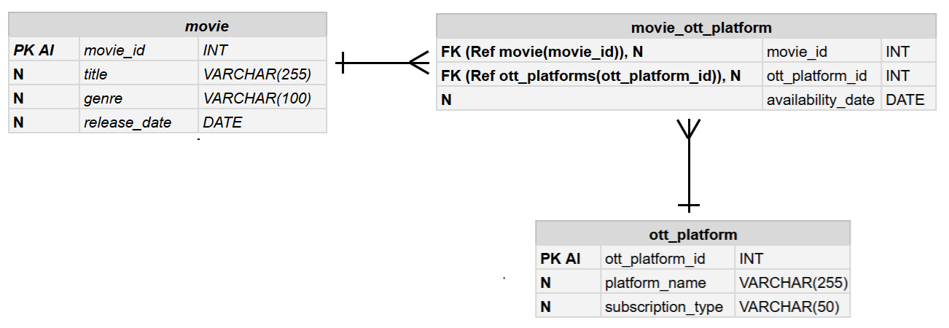

A movie can be available on multiple OTT platforms(one-to-many), and each OTT platform can host multiple movies(one-to-many). This relationship(many-to-many) is handled through the **movie_ott_platform** table, which links **movie_id** and **ott_platform_id**.

**Wireframe**

Home Page-

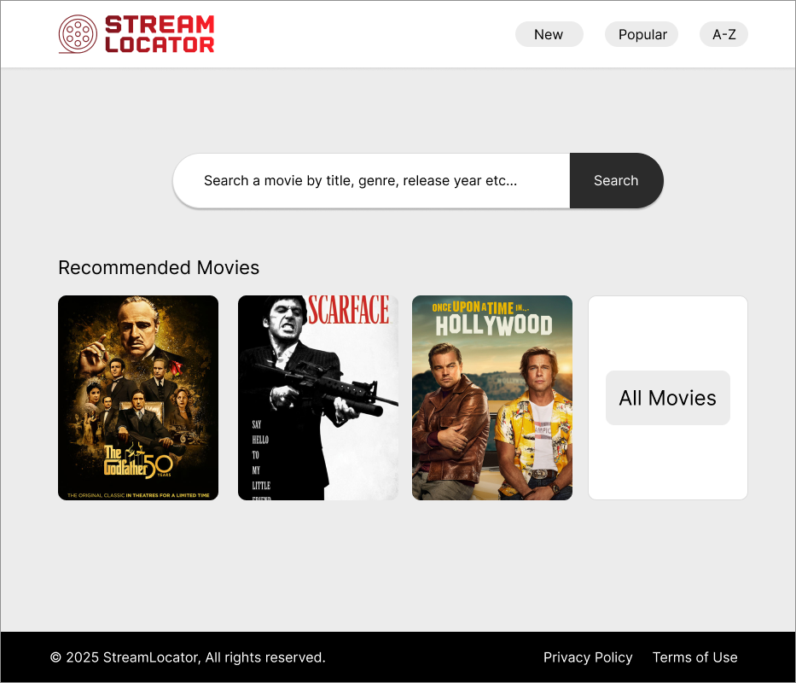

Movie Detail Page-

